RGB LED Interfacing to Arduino:

Introduction:
The RGB led aka the tricolor led is a led that can help generate a multitude of colors by mixing red, blue & green colors. Its more like 3 leds (red, green & blue) put together into a single led.It has 4 pins with 1 of the pins being a common cathode and the other 3 pins acting as anodes for the 3 different colours. by varying the intensity of each of the 3 colours individually, we can generate various colours. This led is the same as 1 pixel of a LED TV!.
Requirment:
- RGB LED
- Current Limiting Resistor
- Arduino Board
- Breadboard

Hardware configuration:
RGB LED as lock like this as given below.
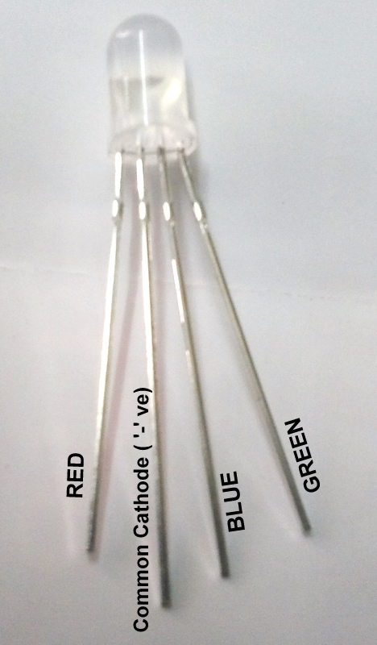
.

step1: place the RGB LED to the breadboard.
Step2:Place resistor between the common cathode and the '-'ve terminal of breadboard.
Step3:Connect RED to Pin 11, Blue to Pin 10 & Green to Pin 9 on the Arduino (these are PWM pins. And aslo proper ground pin of Arduino connected to the breadboard -ve terminal.

Programing:(source code)

Programming to control the RGB LED:

/*
RGB_Blink
Turns on each ofthe color spectrums for 4 seconds,repeatedly.
*/

void setup() {
// initialize the digital pins as an output.
pinMode(11, OUTPUT);
pinMode(10, OUTPUT);
pinMode(9, OUTPUT);
}

void loop() {
digitalWrite(9,LOW);
digitalWrite(11, HIGH);
delay(4000);
digitalWrite(11, LOW);
digitalWrite(10, HIGH);
delay(4000);
digitalWrite(10, LOW);
digitalWrite(9, HIGH);
delay(4000);
}

Installation:
The source code copy to the skeches of arduino and compile (there is verify option) and then uploding the source code.(there is uploding option) to the Arduino board.

Troubleshooting:
FAQ:
Maintainers:
Duryodhan Aldar (durva.ges@gmail.com)

